**Lab Report 1**

## **Aim**

To go through the basics of image processing tools like reading, displaying, converting colour and doing some arithmetic operations on the medical images.

## **Theory**

### **Reading and Displaying an Image**

* Clear the MATLAB workspace of any variables and clear the command window using the commands *clear;* *close all*; and *clc*;
* Use *imread()* to read image files into a matrix in MATLAB. Once you imread an image, it is stored as an ND-array in memory.
* Use *size()* to see the property of image matrix like dimensions and colour bit in MATLAB.
* Use *imshow()* to show the image.

##### **CODE**

img=imread('read.png');

[x,y]=size(img);

imshow(img);

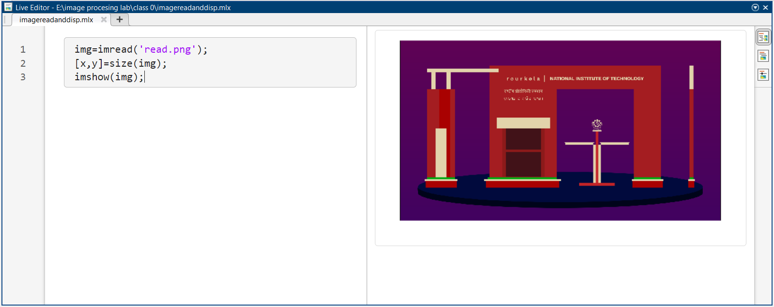

Figure 1: use of imread( ) and imshow( ) function in MATLAB

### **Image Arithmetic**

* As images are represented in a matrix format to perform image arithmetic the size of images should be same. Operation on two images leads to a new image
* Use *imadd()* to add two image files. The corresponding value of the matrix of two images are added and in return we get a new image. We can also use a constant value instead of image, this will add the image pixels with a constant. The two images should be of same dimension to do the addition as it involves the matrix addition.
* Use *imsubtract()* to subtract two image files.
* Use *immultiply()* to multiply two files. The corresponding value of the matrix of two images are multiplied and the resultant image is a new image. The two images should be of same dimension to do the multiply as it involves the matrix. We can also use a constant value instead of image, this will multiply the image pixels with a constant. If the pixel values are fractional then it will round it off to nearest value
* Use *imdivide()* to divide two or more image files.

##### **CODE**

img1=imread('mypic1.png')

img2=imread('mypic2.png')

j=imadd(img1,img2)

subplot(1,3,1);imshow(img1);title("image 1")

subplot(1,3,2);imshow(img2);title("image 2")

subplot(1,3,3);imshow(j);title("added images")

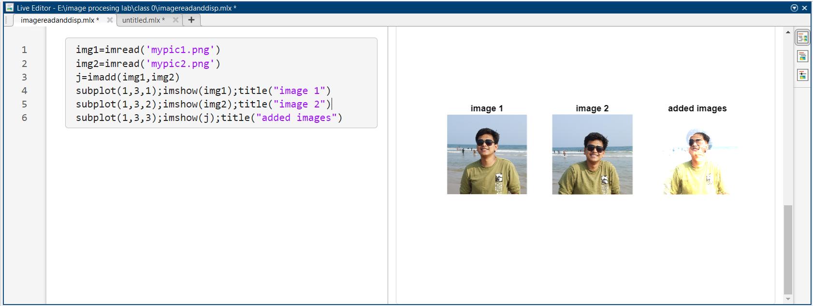

Figure 2: use of imadd( ) to add two images in in MATLAB

##### **CODE**

img1=imread('mypic1.png')

img2=imread('mypic3.png')

j=imsubtract(img1,img2)

subplot(1,3,1);imshow(img1);title("image 1")

subplot(1,3,2);imshow(img2);title("image 2")

subplot(1,3,3);imshow(j);title("subtracted images")

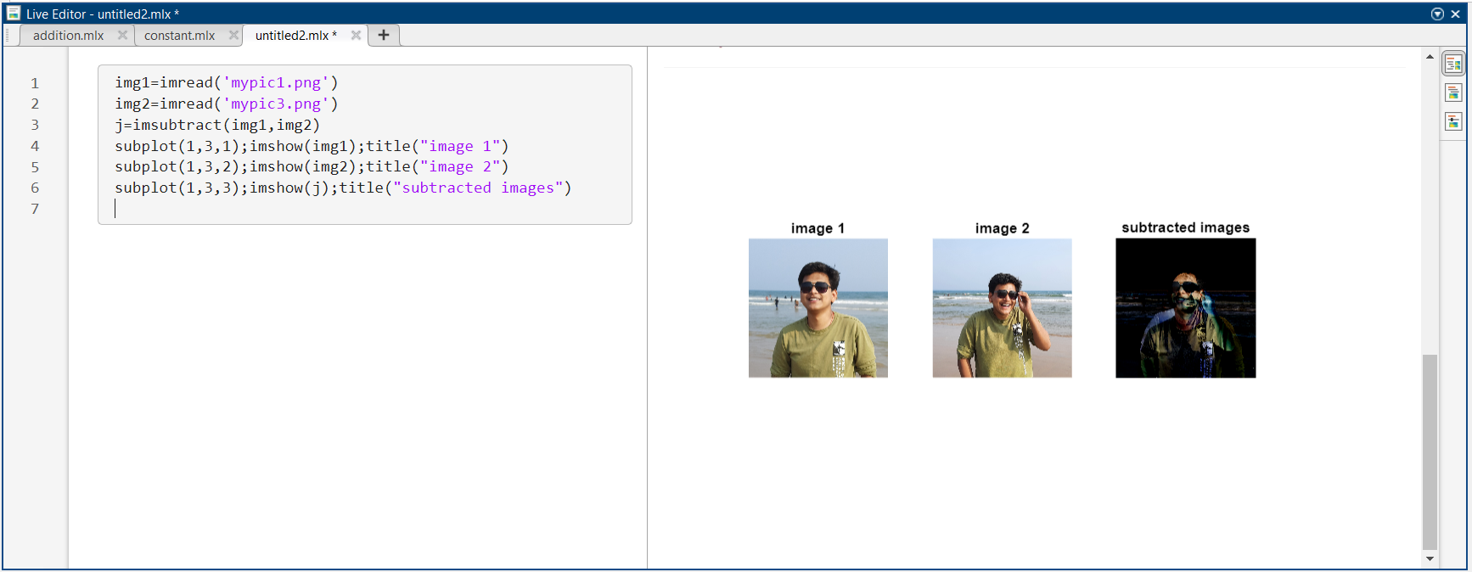

Figure 3: use of imsubtract( ) to subtract two images in in MATLAB

##### **CODE**

img1=imread('mypic1.png')

i=imadd(img1,-100);

j=imadd(img1,-50);

k=imadd(img1,50);

l=imadd(img1,100);

subplot(3,2,1);imshow(img1);title('Original Image');

subplot(3,2,3);imshow(j);title('constant value=-50');

subplot(3,2,4);imshow(i);title('constant value=-100');

subplot(3,2,5);imshow(k);title('constant value= 50');

subplot(3,2,6);imshow(l);title('constant value= 100');

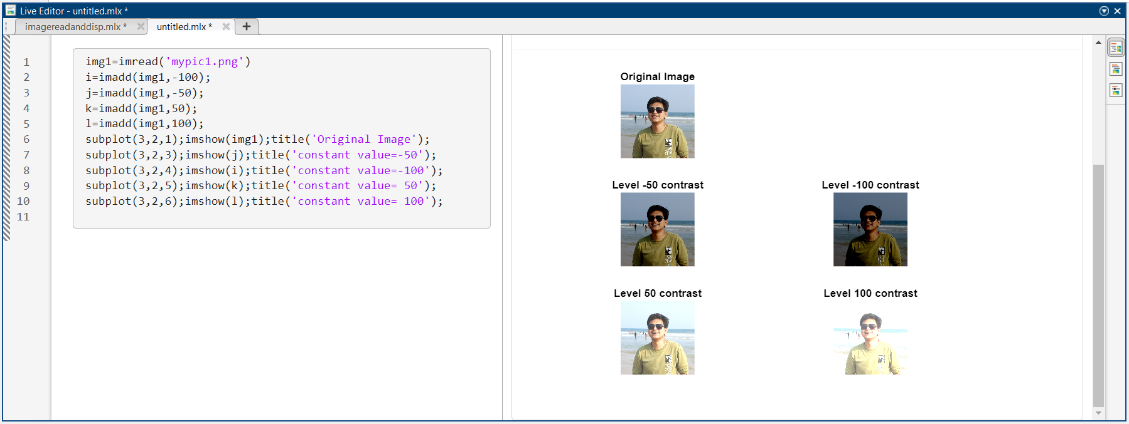

Figure 4: use of imadd( ) to add constant to image in MATLAB

##### **CODE**

img1=imread('mypic1.png')

img2=imread('mypic2.png')

j=immultiply(img1,img2)

subplot(1,3,1);imshow(img1);title("image 1")

subplot(1,3,2);imshow(img2);title("image 2")

subplot(1,3,3);imshow(j);title("multipled images")

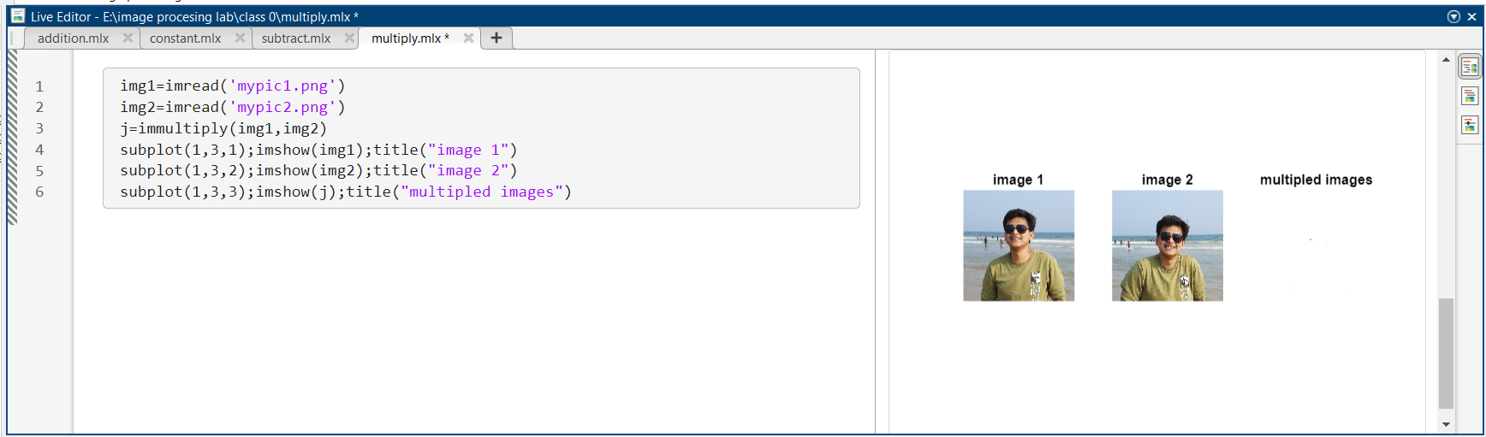

Figure 5: use of immultiply( ) to multiply two images in in MATLAB

##### **CODE**

img1=imread('mypic1.png')

img2=imread('mypic2.png')

j=imdivide(img1,img2)

subplot(1,3,1);imshow(img1);title("image 1")

subplot(1,3,2);imshow(img2);title("image 2")

subplot(1,3,3);imshow(j);title("divided images")

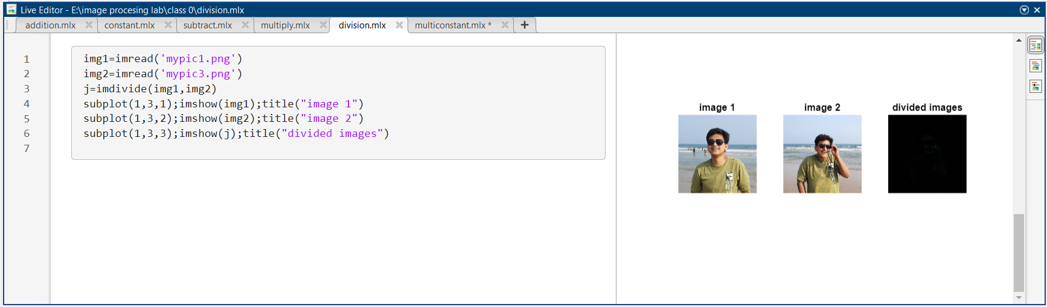

Figure 6: use of imdivide( ) to divide two images in  in MATLAB

##### **CODE**

img1=imread('mypic1.png')

i=immultiply(img1,0.5);

j=immultiply(img1,0.25);

k=immultiply(img1,2.5);

l=immultiply(img1,5);

subplot(3,2,1);imshow(img1);title('Original Image');

subplot(3,2,3);imshow(j);title('constant value= 0.5');

subplot(3,2,4);imshow(i);title('constant value= 0.25');

subplot(3,2,5);imshow(k);title('constant value= 2.5');

subplot(3,2,6);imshow(l);title('constant value= 5'); 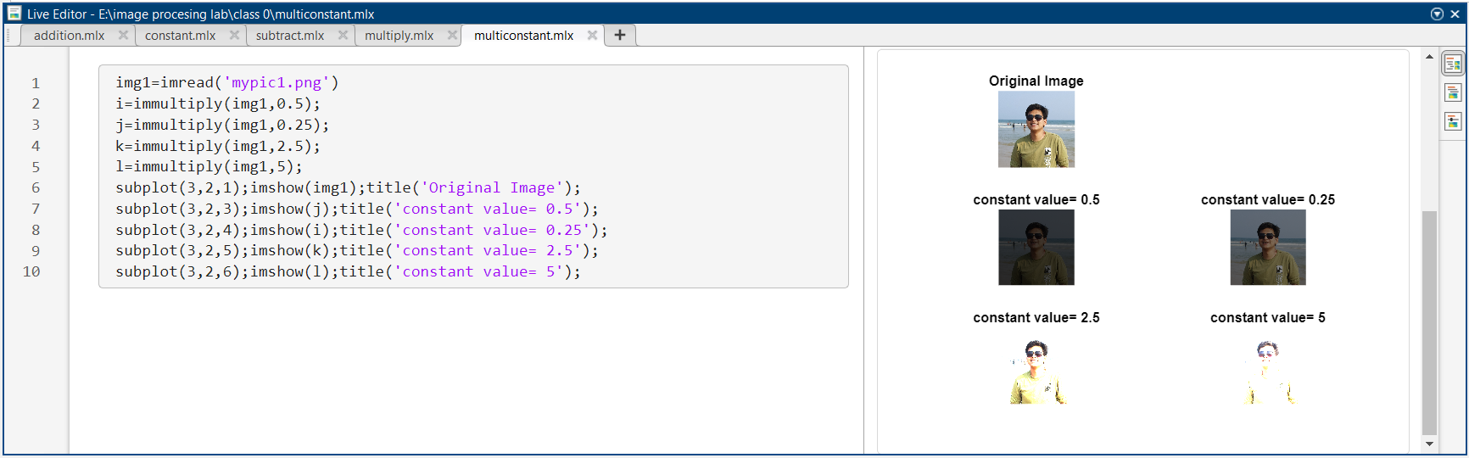

Figure 7: use of immultiply( ) to multiply a constant to images in  in MATLAB

### **Image Histogram**

* An image histogram is a gray-scale value distribution showing the frequency of occurrence of each gray-level value.
* *imhist()* displays a plot of the histogram. If the input image is an indexed image, then the histogram shows the distribution of pixel values above a color bar of the colormap cmap.
* The following code describes how to plot a histogram of an image without the inbuilt function.

##### **CODE**

j=imread('xray.jpg'); *% here we are reading the image*

i=rgb2gray(j); *% here we are converting the RGB image to gray scale*

[rows,column]=size(i); *% we are accessing the image size*

histvalue=zeros(1,255);*%* *creating a zero matrix to store the frequency*

for Rows =1:rows *% to traverse through each row of the image*

for Columns=1:column *% to access each element of the row*

x=i(Rows,Columns); *% assigning a variable the intensity value*

histvalue(1,x+1)=histvalue(1,x+1)+1; %*updating the frequency*

end

end

*%plotting the original image and the histogram*

k=0:1:254;

subplot(2,1,1); imshow(j);title('The image')

subplot(2,1,2); plot(k,histvalue);title('Histogram of image');grid on;

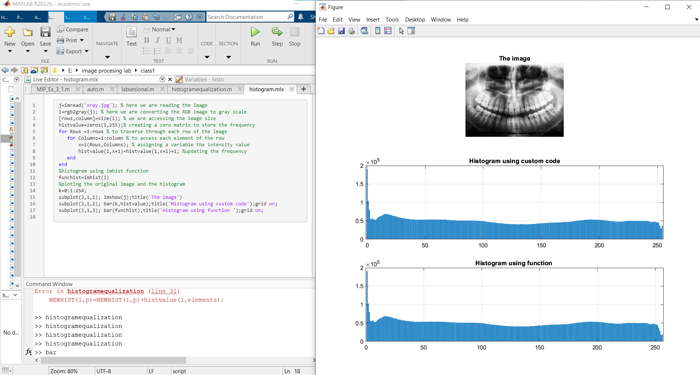

Figure 8: code for plotting the histogram of an image in MATLAB

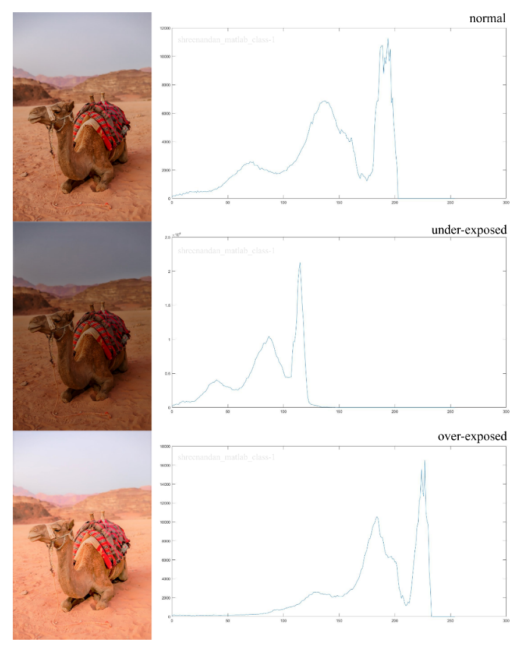

Figure 9: Variation in the histograms of normal, underexposed and over exposed images.

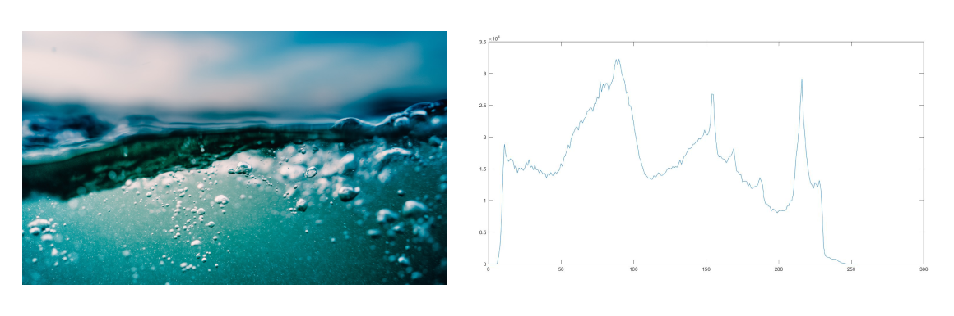

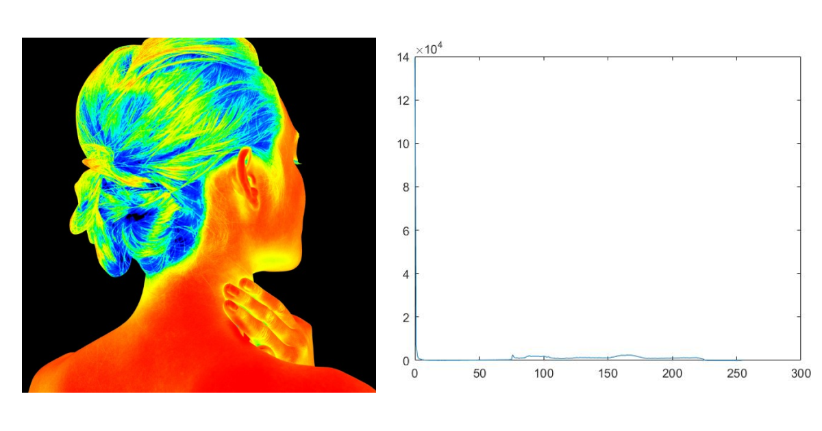Figure 10: Histograms of underwater images.

Figure 11: Histogram of thermal images.

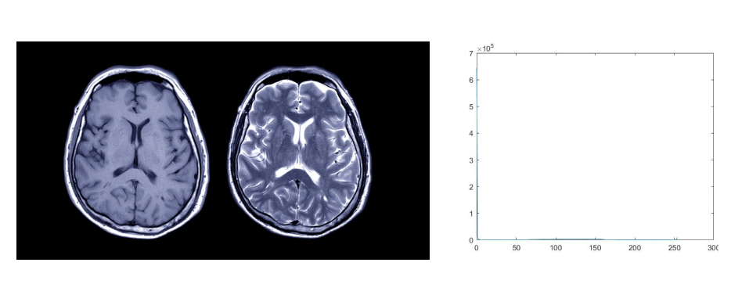

Figure 12: Histogram of medical image (MRI both T1 and T2 waited images).

**Exercise(Assignment)**

### **Exrcise1**.

* B = flip(A,dim) reverses the order of the elements in A along dimension dim. For example, if A is a matrix, then flip(A,1) reverses the elements in each column, and flip(A,2) reverses the elements in each row.

##### **CODE**

img=imread("mypic3.png");

i1=flip(img,1); % this flips the iamge horizontally

i2=flip(img,2); %this flips the image vertically

i3=flip(i1,2);%this flip the image both horizontally and vertically

subplot(2,2,1);imshow(img);title('Original Image');

subplot(2,2,2);imshow(i1);title('horizontally fliped');

subplot(2,2,3);imshow(i2);title('vertically fliped');

subplot(2,2,4);imshow(i3);title('flipped both wise');subplot(3,2,6);imshow(l);title('constant value= 5');

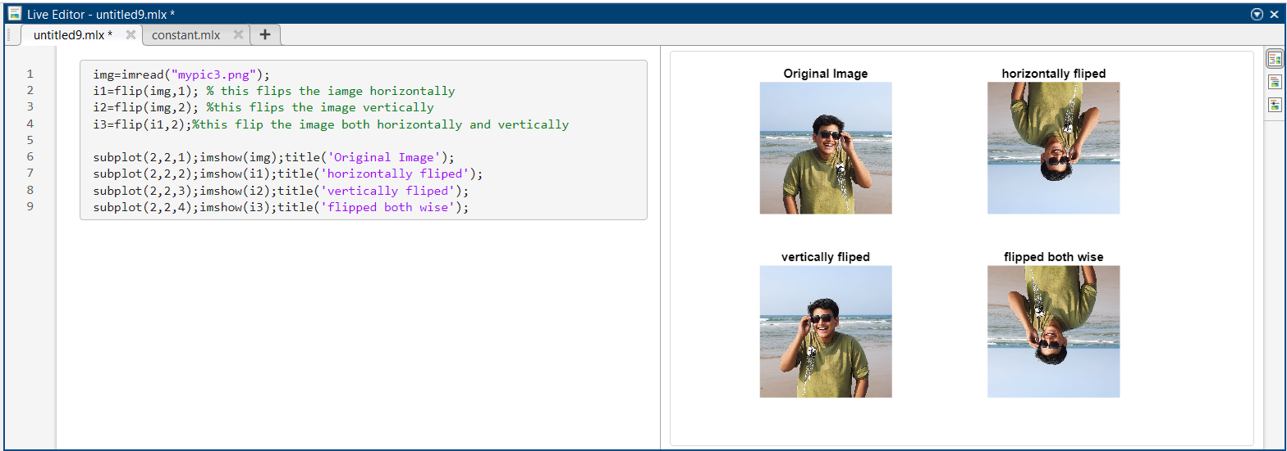

Figure 13: use of flip( ) to flip images  in MATLAB

### **Histogram Equalization**

* 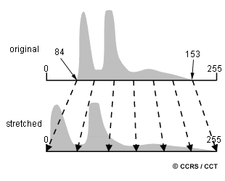Histogram Equalization is a computer image processing technique used to improve contrast in images. It accomplishes this by effectively spreading out the most frequent intensity values, i.e. stretching out the intensity range of the image. This method usually increases the global contrast of images when its usable data is represented by close contrast values. This allows for areas of lower local contrast to gain a higher contrast.

Figure 14: graphical depiction of histogram equalization.

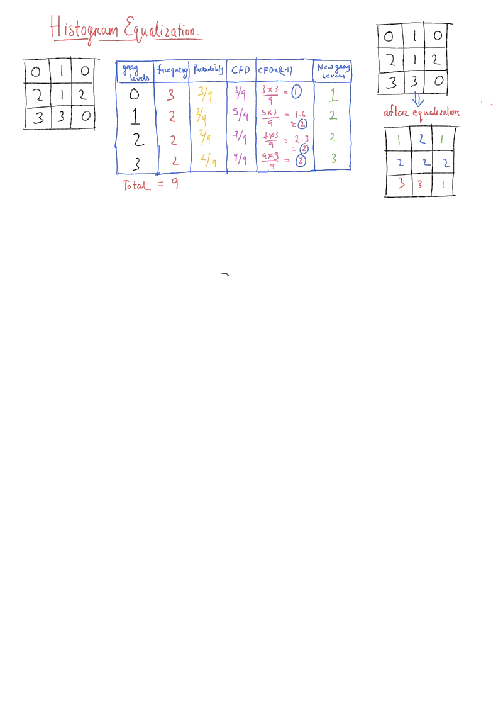

Figure 15: process of finding histogram equalization.

##### **CODE**

y=uigetfile('*.*');

j=imread(y);

i=rgb2gray(j);

rows=height(i);

column=width(i);

histvalue=zeros(1,256);

for Rows =1:rows

for Columns=1:column

x=i(Rows,Columns);

histvalue(1,x+1)=histvalue(1,x+1)+1;

end

end

*%histogram ends here-----------------------------------*

*%probability ------------------------------------------*

px=zeros(1,256);

for columns=1:256

px(1,columns)=histvalue(1,columns)/(rows*column);

end

*%cfd finding ------------------------------------------*

cdf=zeros(1,256);

cumulative=0;

for columns=1:256

cdf(1,columns)=px(1,columns)+cumulative;

cumulative=cumulative+px(1,columns);

end

*%cfd normalising --------------------------------------*

CDF=255*cdf;

newhist=round(CDF);

NEWHIST=zeros(1,256);

for elements=1:256

newgraylevel=newhist(1,elements)+1;

NEWHIST(1,newgraylevel)=NEWHIST(1,newgraylevel)+histvalue(1,elements);

end

new=histeq(i);

histn=imhist(new);

figure();

k=0:1:255;

subplot(2,2,1);bar(k,imhist(i));title('Histogram using imhist function')

subplot(2,2,2);bar(k,histvalue);title('Histogram using custom code')

subplot(2,2,3);bar(histn);title('Histogram eualization using histeq function')

subplot(2,2,4);bar(k,NEWHIST);title('Histogram eualization using custom code')

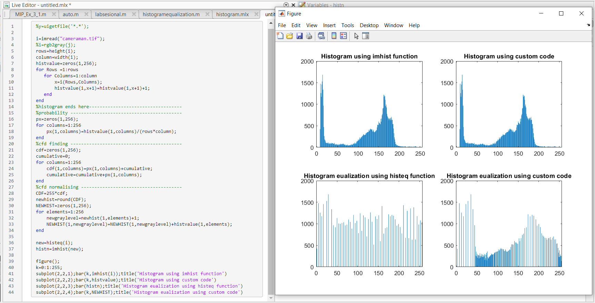

Figure 16: plots showing histograms before and after equalization.

### **Auto Focus**

* Autofocus is the process of improving the image quality on the basis of sharpness of the image. Image which is sharp will have frequency (change in intensity) more as compared to an image of same dimension and same content with less blur.
* By calculating the frequency over all the pixel, we can conclude which image is more focused.

##### **CODE**

function [temp]=autofocus(b)

[m n]=size(b);

temp=double(0);

for i=1:m-1

for j=1:n

k(i,j)=b(i+1,j)-b(i,j); %substracting the adjacent row pixels%

temp=temp+double(k(i,j));% adding all the differenced pixels%

end

end

end

Function 1:function for calculating the cumulative frequencies.

##### **CODE**

%% reading the images%%%%%

fprintf('\n upload an image1 \n');

x=uigetfile('*.*'); %to get access to the image

X=imread(x); %read the image

fprintf('\n upload 2nd image\n');

y=uigetfile('*.*'); % to get access to the image

Y=imread(y); % read the image

s1=size(X); % to find the size of the image

if length(s1)==3 % to find it is color image or gray scale image

X=rgb2gray(X); %if color image convert it into gray scale

end

s2=size(Y); % to find the size of the image

if length(s2)==3 % to find it is color image or gray scale image

Y=rgb2gray(Y); %if color image convert it into gray scale

end

%% auto focusing %%%%%%%%%%%%

k1=autofocus(X); %call for auto focus function

k2=autofocus(Y);

temp=0;

while(k2>k1)

fprintf('\n present image is better focused than previous image');

R=input('still u want to check then type 1 if not 0\n'); % giving input 1 or 0

if(R==1)

fprintf('\n upload another image\n');

x1=uigetfile('*.*');

X1=imread(x1); %if input is 1 read another image

s3=size(X1); %to find size of the image

if length(s3)==3

X1=rgb2gray(X1); % changing color image to gray

end

k2=autofocus(X1); % call for auto focus function

else

fprintf('\n present image is best focused\n');

temp=1;

break;

end

end

if(temp==0)

fprintf('\n previous image is better focused than present image\n go to the back step\n');

endend

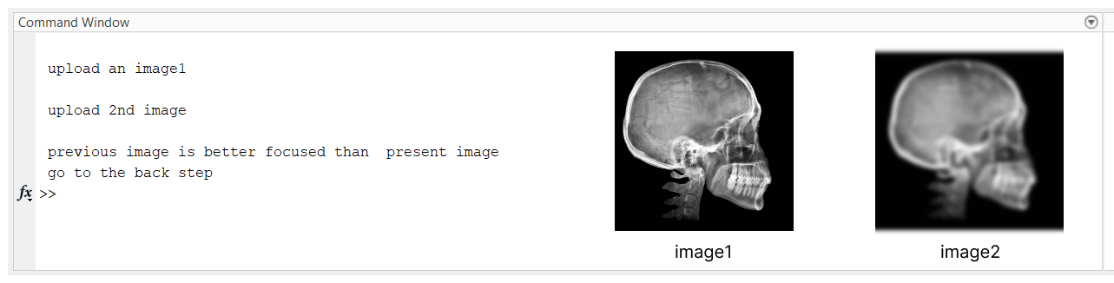

Figure 17: command window showing which image is more focused.

---------------------------------------------

Shreenandan Sahu |120BM0806